|  |  |
| --- | --- |
| **Assignment Case** |  |
| COMP6175 | T0044  Object Oriented Programming |
| **Computer Science** | **E203-COMP6175-LC00204-01** |
| ***Valid on*** *Even Semester Year 2019/2020* | **Revision 00** |

## Soal

*Case*

**FashionNova**

**FashionNova** is a cloth shopping system that allows you tohelp sellers to manage their shop. You as a programmer are asked to make **FashionNova** using **Java Programming Language** with the following specifications:

First, the program will print the **main menu** that consists of:

1. **View Catalogue**
2. **Sell Product**
3. **Add Product to Catalogue**
4. **Exit**

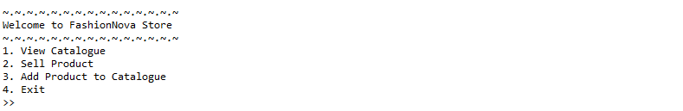

1. If the user chooses **View Catalogue (Menu 1)**, then:

* If **there’s available product**, then the program will show list of cloth’s information:
  + **Cloth ID**
  + **Cloth Name**
  + **Cloth Material**
  + **Stock**
  + **Cloth Price**

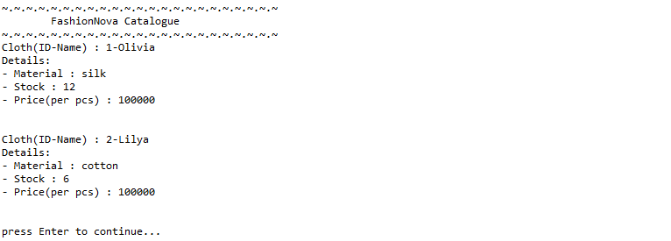

* If there’s **No available product**, then the program will print **“Nothing to display here”**



1. If the user chooses **Sell Product (Menu 2)**, then:

* If **there’s available product**, the program will ask user to input:
  + **Cloth Id,** which is **numeric** and must **exist** in clothes list
  + **Quantity,** which is **numeric** and **validate** input **between 1 and current available stock**

After that, the program will print:

* + **Price,** which you can getfrom the following formula:

**Price = Cloth Price * Quantity**

* + **Tax,** which you can get from the following formula:

**Tax = Price * 10%**

* + **Total Price,** which you can get from the following formula:

**Total Price = Price + Tax**

Finally, the program will print **“[Quantity] item(s) of [Cloth Name] sold successfully!”**

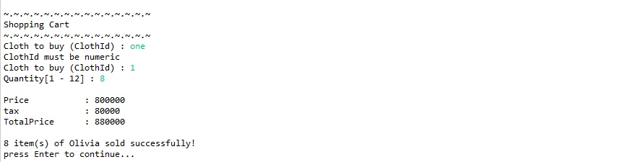

* If **there’s no available product**, the program will print **“No clothes on our store right now”**



1. If the user chooses **Add Product to Catalogue (Menu 3)**, then:

* The program will ask user to **input** the following data:
* **Cloth Id**, which is **numeric between 1 – 100** and must be **unique**
* **Cloth Name** which **length** must be **between 5 – 25 characters**
* **Cloth Material,** must be either **“cotton” or “silk”** (case sensitive)
* **Stock,** which is **numeric** and must b**etween 5 - 50**
* **Cloth Price,** which is **numeric** with **minimum price of 100000**
* Finally, the program will **save the cloth** into the clothes list and **show message “Cloth successfully added!”**.

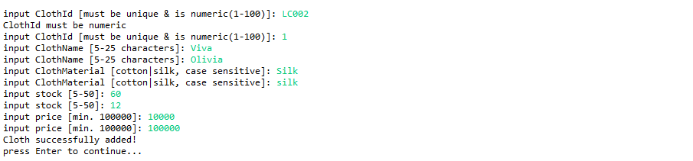

1. If the user chooses **Exit (Menu 4)**, the program will print message “**Thank you for using FashionNova program!**” and exit.

**Please run the EXE file to see the sample program.**